Introduction:
Twin-rotor multi-input multi-output system (commonly abbreviated as TRMS) is an experimental, reduced model of a helicopter that has two degrees of freedom. The main component of the system is a beam that carries two rotors having rotation axes orthogonal to each other (see Fig. 1). The propellers mounted on the rotors produce thrust which is needed to move the system on yaw and pitch axes. The overall system is obviously nonlinear and very complex due to significant cross-coupling.
Classical control techniques such as combinations of proportional (P), integral (I), derivative (D) controllers were used commonly to control TRMS.
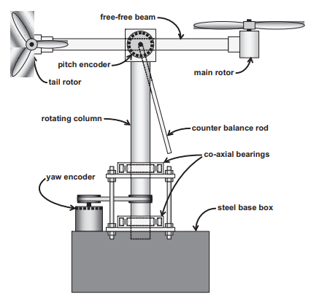
The Twin-Rotor Multi-Input Multi-Output System (TRMS) utilizes several key mechanical components that are essential for its operation. Below is a detailed overview of these components:
1. Mechanical Frame
- Carrier Column: The structure is mounted on a steel base box and equipped with two co-axial ball bearings, allowing for precise movement.
- Free-Free Beam: An aluminium square tubing positioned atop the carrier column; it allows pitch angle variations between -40 to +40 degrees.
- Steel Shaft: Fixed at the centre of the beam, it is supported by brass bearings on both sides, providing stability.
- Positioning Mechanism: Tight fitting of moving parts is crucial for maintaining accuracy in positioning.
2. Thrust System
- Main Rotor: Produces vertical thrust and enables the beam to rotate around the pitch axis.
- Tail Rotor: Mounted orthogonally to the main rotor, it generates thrust around the yaw axis.
- DC Motors: Both rotors are powered by DC motors housed in plastic casings attached to the beam.
- Propeller Design: The main rotor's radius is double that of the tail rotor, optimized for lifting the counterbalance effectively [4].
3. Sensors and Control Elements
- Pitch Angle Sensor: Mounted on the steel shaft to monitor and control the pitch movements.
- Counterbalance: Attached to the beam to maintain stability and control during operation.
- Control Algorithms: Classical control techniques, including PID and fuzzy logic controllers, are often utilized to manage the system effectively.
4. Additional Components
- Ball Bearings: Essential for facilitating smooth movement of the mechanical frame.
- Electrical Connections: Designed to avoid costly slip rings while allowing for necessary rotation.

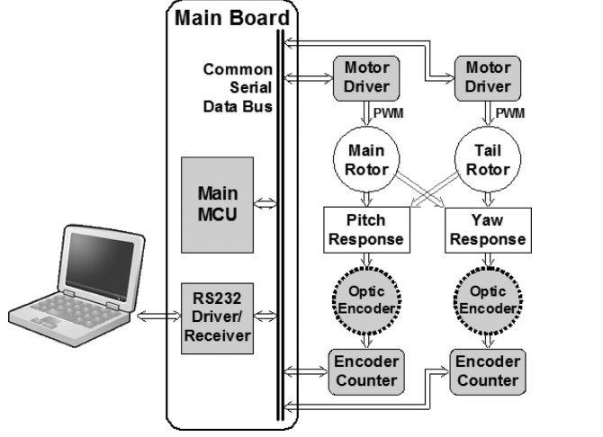
The development of the Twin-Rotor Multi-Input Multi-Output System (TRMS) involved several software development practices aimed at creating a robust control system. Key practices included:
- Use of Development Environments: The controller program was developed using the LabVIEW Development Environment, selected for its real-time display capabilities and ease of serial communication [6].
- Control Algorithms Implementation: Various control algorithms were employed, including classical techniques like Proportional-Integral-Derivative (PID) controllers and advanced methods such as fuzzy PID controllers to enhance performance.
- Dynamic Modelling: The software incorporated dynamic modelling of the TRMS, utilizing both physics-based methods and artificial intelligence techniques, including neural networks and genetic algorithms, to improve model accuracy [5].
- User Interface Design: A user-friendly interface was created within LabVIEW, allowing real-time monitoring of control inputs, tracking errors, and adjustments to control gains and target positions [6].
- Integration of Hardware with Software: The software was designed to interface seamlessly with the hardware components, ensuring that the control signals could effectively manage the rotors' operations.
- Real-Time Monitoring and Feedback: The system provided real-time feedback on performance metrics, enabling immediate adjustments to improve control accuracy.
- Testing and Validation: Preliminary experiments were conducted to validate the software's performance and its effectiveness in controlling the TRMS.
- Collaboration and Team Involvement: The development process included collaboration among team members, including undergraduate students who gained hands-on experience in various aspects of control systems [8].
Summary of Key Features
- Modular Design: The software architecture supported modular design, allowing for easier updates and maintenance.
- Robust Control Strategies: Implementation of robust controllers to handle uncertainties and disturbances in the system.
- Adaptive Learning: Use of adaptive algorithms to refine control strategies based on real-time data and performance outcomes.
- Documentation and Training: Comprehensive documentation was created for both the software and hardware components, facilitating training and knowledge transfer.

